**dados_svm**

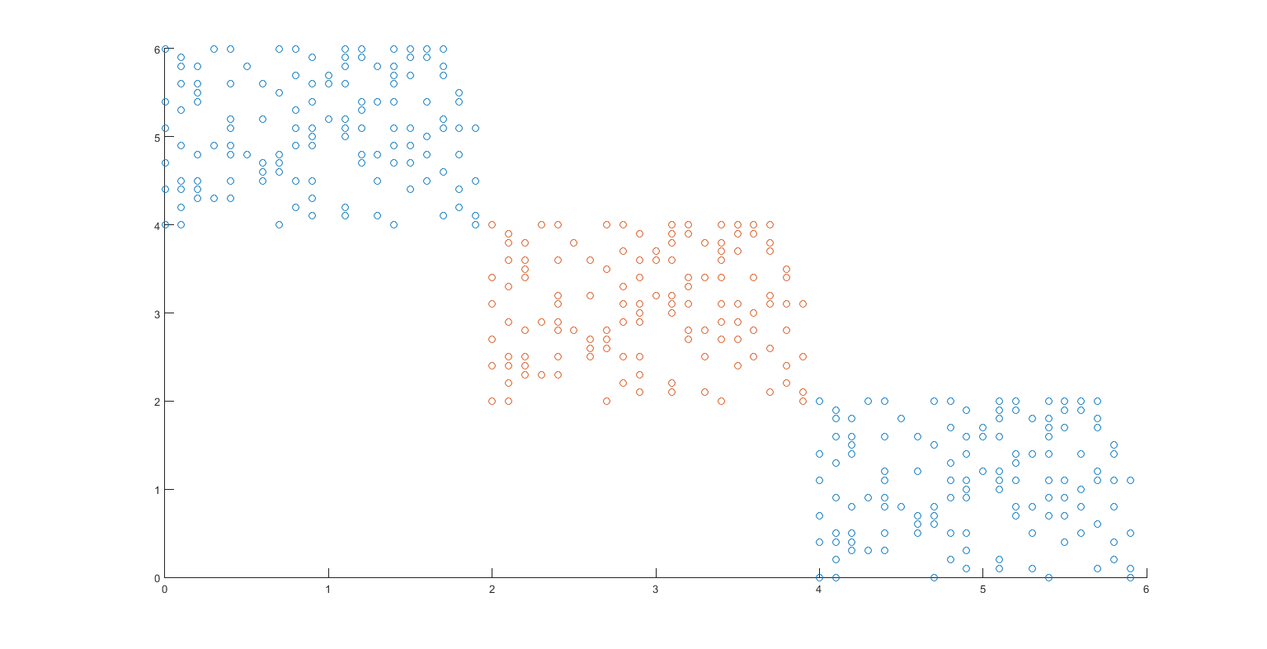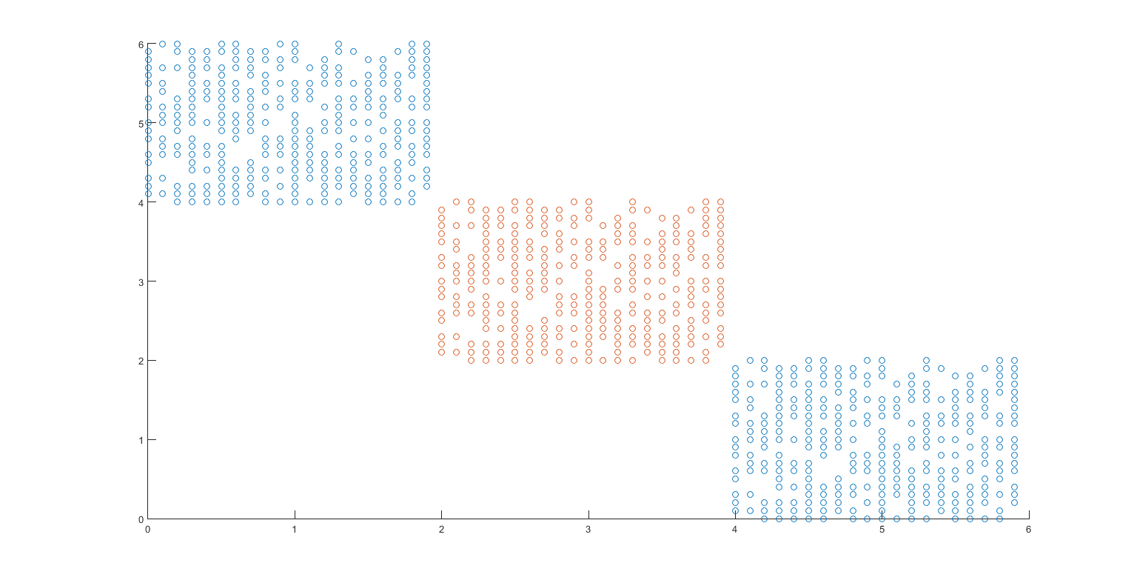

**Kernel**

Ker = 'rbf';

param = .2;

C = 1;

tol = 0.002;

max_passes = 1;

**Treinamento**

acertos: 882

erros: 0

acurácia: 1.00

confMatrix =

|  |  |  |
| --- | --- | --- |
|  | **1** | **-1** |
| **1** | 588 | 0 |
| **-1** | 0 | 294 |

**Teste**

acertos: 378

erros: 0

acuracia: 1.00

confMatrix =

|  |  |  |
| --- | --- | --- |
|  | **1** | **-1** |
| **1** | 252 | 0 |
| **-1** | 0 | 126 |

**Comparação com matriz de kernel e sem**

|  |  |  |  |  |
| --- | --- | --- | --- | --- |
|  | Max Passes | Time Kernel | Time Training | Total Time |
| Sem Matrix de Kernel | 1 | - | 2.2575 | 2.2575 |
| 50 | - | 58.3528 | 58.3528 |
| 100 | - | 97.4784 | 97.4784 |
| Com Matrix de Kernel | 1 | 19.1168 | 0.1722 | 19,289 |
| 50 | 19.1168 | 6.4976 | 25,6144 |
| 100 | 19.1168 | 14.1272 | 33,244 |

**q1x**

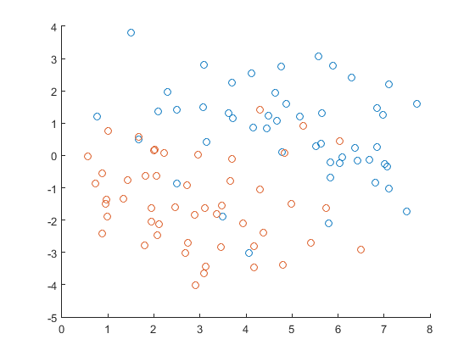

**Kernel**

Ker = 'rbf';

param = .2;

C = 10;

tol = 0.002;

max_passes = 3;

**Treinamento**

acertos: 99

erros: 0

acurácia: 1.00

confMatrix =

|  |  |  |
| --- | --- | --- |
|  | **1** | **-1** |
| **1** | 49 | 0 |
| **-1** | 0 | 50 |

|  |  |  |
| --- | --- | --- |
|  | **Prediction** | |
| **True Value** | TP | FN |
| FP | TN |

**Spambased**

**X – [4601x57]**

**Treinamento (70%) Xtr – [3220x57]**

**Teste (30%) Xts – [1381x57]**

Teste 1

**Kernel**

Ker = 'rbf';

param = .5;

C = 30;

tol = 0.002;

max_passes = 50;

**Treinamento**

acertos: 3219

erros: 1

acurácia: 1.00

confMatrix =

|  |  |  |
| --- | --- | --- |
|  | **1** | **-1** |
| **1** | 1270 | 1 |
| **-1** | 0 | 1949 |

**Teste**

acertos: 971

erros: 410

acurácia: 0.70

confMatrix =

|  |  |  |
| --- | --- | --- |
|  | **1** | **-1** |
| **1** | 133 | 409 |
| **-1** | 1 | 838 |

Teste 2

**Kernel**

Ker = 'rbf';

param = 3;

C = 30;

tol = 0.002;

max_passes = 50;

**Treinamento**

acertos: 3210

erros: 10

acurácia: 1.00

confMatrix =

|  |  |  |
| --- | --- | --- |
|  | **1** | **-1** |
| **1** | 1270 | 2 |
| **-1** | 8 | 1940 |

**Teste**

acertos: 1125

erros: 256

acurácia: 0.81

confMatrix =

|  |  |  |
| --- | --- | --- |
|  | **1** | **-1** |
| **1** | 448 | 93 |
| **-1** | 163 | 677 |

Teste 3

**Kernel**

Ker = 'rbf';

param = 10;

C = 200;

tol = 0.002;

max_passes = 50;

**Treinamento**

acertos: 3168

erros: 52

acurácia: 0.98

confMatrix =

|  |  |  |
| --- | --- | --- |
|  | **1** | **-1** |
| **1** | 1251 | 32 |
| **-1** | 20 | 1917 |

**Teste**

acertos: 1203

erros: 178

acurácia: 0.87

confMatrix =

|  |  |  |
| --- | --- | --- |
|  | **1** | **-1** |
| **1** | 451 | 79 |
| **-1** | 99 | 752 |

Teste 4 (Dados normalizados)

**Kernel**

Ker = 'rbf';

param = 10;

C = 200;

tol = 0.002;

max_passes = 50;

**Treinamento**

acertos: 3069

erros: 151

acurácia: 0.95

confMatrix =

|  |  |  |
| --- | --- | --- |
|  | **1** | **-1** |
| **1** | 1178 | 101 |
| **-1** | 50 | 1891 |

**Teste**

acertos: 1269

erros: 112

acurácia: 0.92

confMatrix =

|  |  |  |
| --- | --- | --- |
|  | **1** | **-1** |
| **1** | 461 | 73 |
| **-1** | 39 | 808 |

**Comparação com matriz de kernel e sem**

|  |  |  |  |  |
| --- | --- | --- | --- | --- |
|  | Max Passes | Time Kernel | Time Training | Total Time |
| Sem Matrix de Kernel | 1 | - | 149.7730 | 149.7730 |
| 50 | - | 4775.0291 | 4775.0291 |
| 100 | - | - | - |
| Com Matrix de Kernel | 1 | 300.9311 | 7.2422 | 308.1733 |
| 50 | 300.9311 | 249.1821 | 550.1132 |
| 100 | 300.9311 | 516.9371 | 817.8682 |

**Iris – Biclass (Setosa e Versicolor)**

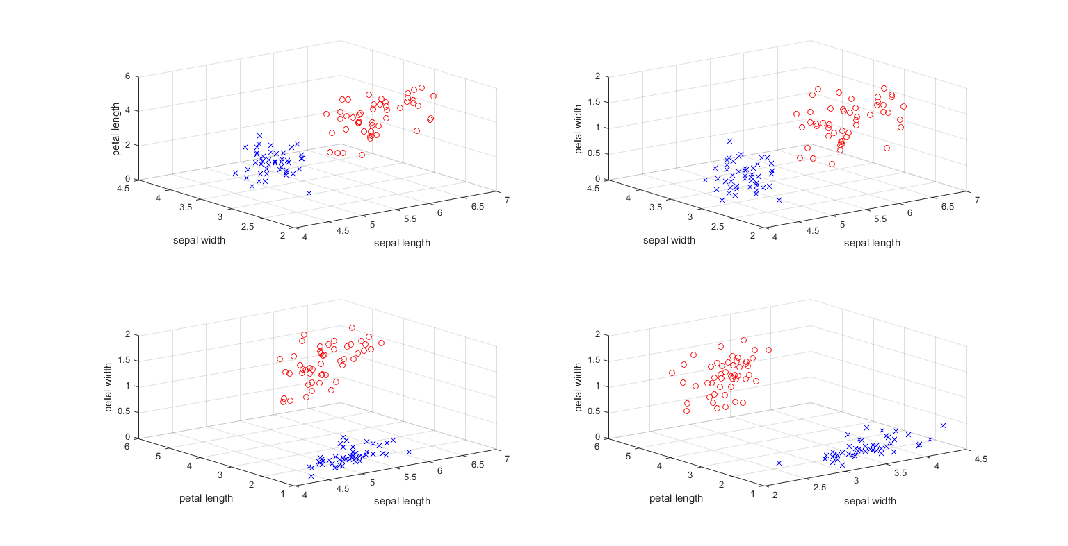

**Kernel**

Ker = 'rbf';

param = 1;

C = 1;

tol = 0.002;

max_passes = 1;

**Treinamento**

acertos: 70

erros: 0

acurácia: 1.00

confMatrix =

|  |  |  |
| --- | --- | --- |
|  | **1** | **-1** |
| **1** | 36 | 0 |
| **-1** | 0 | 34 |

**Teste**

acertos: 30

erros: 0

acuracia: 1.00

confMatrix =

|  |  |  |
| --- | --- | --- |
|  | **1** | **-1** |
| **1** | 14 | 0 |
| **-1** | 0 | 16 |

**Iris – Multiclass**

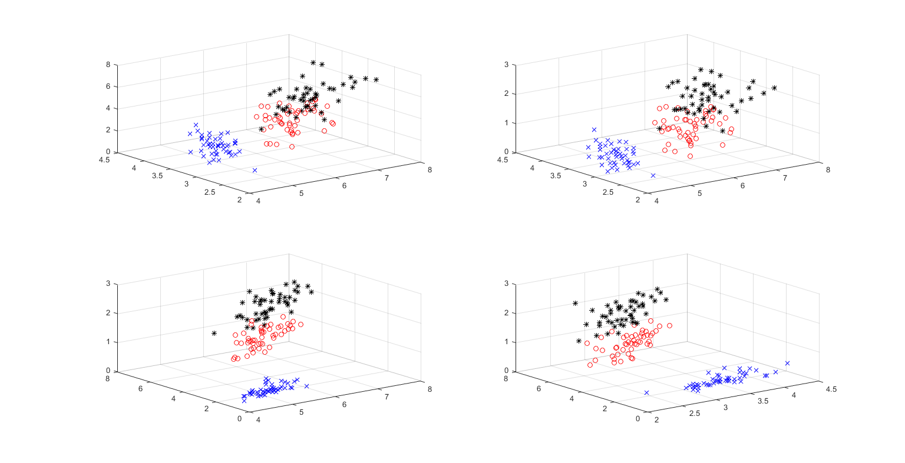

**Kernel**

Ker = 'rbf';

param = 1;

C = 1;

tol = 0.000020;

max_passes = 50;

**Treinamento**

acertos: 104

erros: 1

acurácia: 0.99

confMatrix =

|  |  |  |  |
| --- | --- | --- | --- |
|  | **1** | **2** | **3** |
| **1** | 33 | 0 | 0 |
| **2** | 0 | 34 | 1 |
| **3** | 0 | 0 | 37 |

**Teste**

acertos: 43

erros: 2

acuracia: 0.96

confMatrix =

|  |  |  |  |
| --- | --- | --- | --- |
|  | **1** | **2** | **3** |
| **1** | 17 | 0 | 0 |
| **2** | 0 | 13 | 2 |
| **3** | 0 | 0 | 13 |

**Path-based**

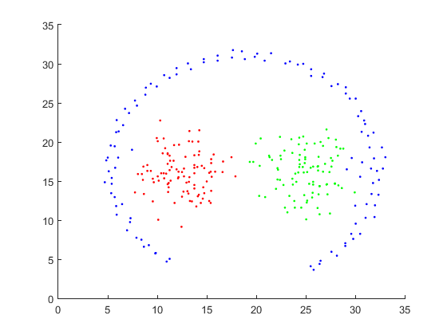

**Kernel**

Ker = 'rbf';

param = .2;

C = 1;

tol = 0.000020;

max_passes = 50;

**Treinamento**

acertos: 210

erros: 0

acurácia: 1.00

confMatrix =

|  |  |  |  |
| --- | --- | --- | --- |
|  | **1** | **2** | **3** |
| **1** | 76 | 0 | 0 |
| **2** | 0 | 69 | 0 |
| **3** | 0 | 0 | 65 |

**Teste**

acertos: 89

erros: 1

acuracia: 0.99

confMatrix =

|  |  |  |  |
| --- | --- | --- | --- |
|  | **1** | **2** | **3** |
| **1** | 34 | 0 | 0 |
| **2** | 0 | 27 | 1 |
| **3** | 0 | 0 | 28 |

**Path-based2**

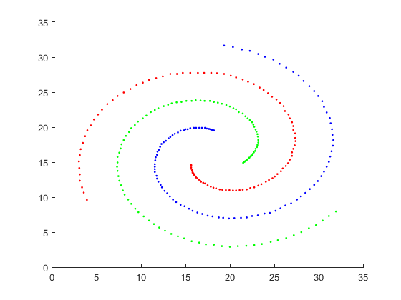

**Kernel**

Ker = 'rbf';

param = .5;

C = 1;

tol = 0.000020;

max_passes = 50;

**Treinamento**

acertos: 219

erros: 0

acurácia: 1.00

confMatrix =

|  |  |  |  |
| --- | --- | --- | --- |
|  | **1** | **2** | **3** |
| **1** | 75 | 0 | 0 |
| **2** | 0 | 74 | 0 |
| **3** | 0 | 0 | 70 |

**Teste**

acertos: 93

erros: 0

acuracia: 1.00

confMatrix =

|  |  |  |  |
| --- | --- | --- | --- |
|  | **1** | **2** | **3** |
| **1** | 26 | 0 | 0 |
| **2** | 0 | 31 | 0 |
| **3** | 0 | 0 | 36 |

**Wine Quality**

Teste 1

Distribuição do Dataset:

Value Count Percent

3 10 0.63%

4 53 3.31%

5 681 42.59%

6 638 39.90%

7 199 12.45%

8 18 1.13%

Conj de Treinamento:

Value Count Percent

3 7 0.63%

4 33 2.95%

5 483 43.13%

6 457 40.80%

7 128 11.43%

8 12 1.07%

Conj de Teste:

Value Count Percent

3 3 0.63%

4 20 4.18%

5 198 41.34%

6 181 37.79%

7 71 14.82%

8 6 1.25%

**Kernel**

Ker = 'rbf';

param = .2;

C = 1;

tol = 0.000020;

max_passes = 50;

**Treinamento**

acertos: 1119

erros: 0

acuracia: 1.00

confMatrix =

|  |  |  |  |  |  |  |
| --- | --- | --- | --- | --- | --- | --- |
|  | **3** | **4** | **5** | **6** | **7** | **8** |
| **3** | 7 | 0 | 0 | 0 | 0 | 0 |
| **4** | 0 | 33 | 0 | 0 | 0 | 0 |
| **5** | 0 | 0 | 483 | 0 | 0 | 0 |
| **6** | 0 | 0 | 0 | 457 | 0 | 0 |
| **7** | 0 | 0 | 0 | 0 | 128 | 0 |
| **8** | 0 | 0 | 0 | 0 | 1 | 11 |

**Teste**

acertos: 263

erros: 216

acuracia: 0.55

confMatrix =

|  |  |  |  |  |  |  |
| --- | --- | --- | --- | --- | --- | --- |
|  | **3** | **4** | **5** | **6** | **7** | **8** |
| **3** | 0 | 0 | 3 | 0 | 0 | 0 |
| **4** | 0 | 0 | 20 | 0 | 0 | 0 |
| **5** | 0 | 0 | 197 | 1 | 0 | 0 |
| **6** | 0 | 0 | 136 | 45 | 0 | 0 |
| **7** | 0 | 0 | 50 | 0 | 21 | 0 |
| **8** | 0 | 0 | 6 | 0 | 0 | 0 |

Teste 2

Distribuição do Dataset:

Value Count Percent

3 10 0.63%

4 53 3.31%

5 681 42.59%

6 638 39.90%

7 199 12.45%

8 18 1.13%

Conj de Treinamento:

Value Count Percent

3 9 0.80%

4 38 3.39%

5 474 42.32%

6 445 39.73%

7 142 12.68%

8 12 1.07%

Conj de Teste:

Value Count Percent

3 1 0.21%

4 15 3.13%

5 207 43.22%

6 193 40.29%

7 57 11.90%

8 6 1.25%

**Kernel**

Ker = 'rbf';

param = 1;

C = 20;

tol = 0.000020;

max_passes = 50;

**Treinamento**

acertos: 1111

erros: 9

acuracia: 0.99

confMatrix =

|  |  |  |  |  |  |  |
| --- | --- | --- | --- | --- | --- | --- |
|  | **3** | **4** | **5** | **6** | **7** | **8** |
| **3** | 9 | 0 | 0 | 0 | 0 | 0 |
| **4** | 0 | 38 | 0 | 0 | 0 | 0 |
| **5** | 1 | 1 | 469 | 3 | 0 | 0 |
| **6** | 0 | 1 | 1 | 442 | 1 | 0 |
| **7** | 0 | 0 | 0 | 0 | 142 | 0 |
| **8** | 0 | 0 | 0 | 0 | 1 | 11 |

**Teste**

acertos: 308

erros: 171

acuracia: 0.64

confMatrix =

|  |  |  |  |  |  |  |
| --- | --- | --- | --- | --- | --- | --- |
|  | **3** | **4** | **5** | **6** | **7** | **8** |
| **3** | 0 | 0 | 0 | 1 | 0 | 0 |
| **4** | 1 | 2 | 6 | 6 | 0 | 0 |
| **5** | 0 | 4 | 153 | 46 | 4 | 0 |
| **6** | 0 | 2 | 52 | 124 | 15 | 0 |
| **7** | 0 | 0 | 10 | 19 | 28 | 0 |
| **8** | 0 | 0 | 3 | 1 | 1 | 1 |